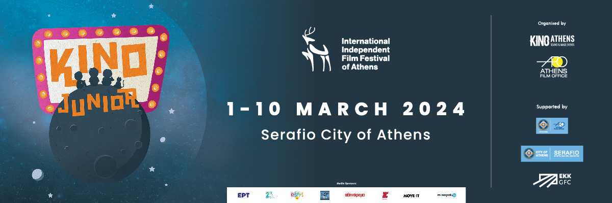

KINO Athens International Independent Film Festival

Section: ΚΙΝΟ JUNIOR
Key Visual and Film Submissions

SUBMISSION DEADLINE: 31.01.2024.

KINO Athens International Independent Film Festival in collaboration with Athens Film Office are introducing a new festival section, the KINO Junior with the support of the City of Athens and the Greek Film Centre. The section is addressed to children and teenagers over 3 years old.

More than 30 films, between shorts and features, will compete for Best Film and Audience' award. There will be a special jury, composed by a group of children aged between 7 and 13 years old, who will award the prize:

>> Deer Kids Award

Workshops and other special activities also will take place in Serafio City of Athens. The KINO Junior section is designed to involve schools and families around inspirational and artistic elevated films made for those ages.

The program is curated by the Portuguese author, teacher and children's program curator, Possidónio Cachapa. The section and school activities is coordinated by artist and animatrice, Iokasti-Agavi Papanikolaou.

The film submission process has also started for children's films.

KINO Athens International Independent Film Festival will take place from March 1 to 10, 2024, at the Serafio City of Athens, Technopolis City of Athens and Michael Cacoyannis Foundation. The KINO Junior section’s activities will take place solely at Serafio City of Athens.

The visual image of the KINO Junior section is the creation of KINO's designer, Aliki Dokou.

The films are submitted online on the KINO Athens platform.

Stay tuned with the news of KINO Athens by subscribing our newsletter.

More information about the festival, terms and conditions on the KINO Athens website.

www.kinoathens.org

and at the
Facebook - Instagram - TikTok

For press matters contact media@kinoathens.com

